# **CATERPILLAR INNOVATION CHALLENGE**

# **REPORT ON RE-VOLT**

**SUBMITTED BY**

**MUNI KUMAR P V**

**SAIMOTISH R**

**KUNAL YADAV**

**VAIBHAV MALANI**

**RE-VOLT**

# **INTRODUCTION**

The laws of thermodynamics place strict limitations on the efficiency of power output that can be drawn from the combustion chamber of an IC engine. The losses that occur later on during the transmission of mechanical power can, however, provide decent scope for being regulated upon by better designing, accurate manufacturing and better control. These losses are what the following design mainly aspires to deduct to a minimal value. The setup of the design consists of an inner piston arrangement and an outer piston arrangement. Each arrangement consists of two pistons rigidly connected by connecting rods with in between them, a magnetic setup for the inner one and a coil for the outer one. The outer pistons are concentric to the inner pistons such that they appear to be hollow cylinders. The pistons are powered by 8 thermodynamic systems, each on either side of a piston between the piston and its enclosure. The frequency of the inner and outer pistons is equal and they oscillate with a phase difference of 180 degrees. The coil moves with the outer pistons and the magnetic setup with the inner pistons. The relative motion between the magnets and the coil induces a Voltage difference between the ends of the coil and hence, electrical energy is transmitted. This design involves the magnet moving linearly within a coil – a setup that has very low mechanical losses when compared to a crankshaft engine. This setup also allows high voltage to be generated with minimal frictional loss as the total frictional loss is split up by eight thermodynamic systems instead of each having its own. A mechanical efficiency of around over 95% can be achieved this way.

### **MOTIVATION**

A generator is a combination of an internal combustion engine and generator (alternator) coupled together. Coupling causes lot of loss in energy that is transmitted from engine to the alternator, thereby, drastically reducing the efficiency. There is always power lost in conversion of mechanical energy to electrical energy. Keeping the power crisis that the world is facing in present we cannot afford to have such loss in transmission which in turn creates the demand to come up with an alternative mechanism to reduce the loss due to coupling and increase the efficiency.

### **OBJECTIVES**

The focus of this project is to come up with an alternative which can convert the flywheel mechanical power of an internal combustion engine to electrical energy without use of coupling by modifying the design of IC engine so as to eliminate external alternator to produce electricity and thereby increasing the efficiency.

### **BACKGROUND THEORY**

***Briefing of Efficiencies:***

An engine involves four types of efficiencies:

* Combustion efficiency (Chemical energy à Thermal energy).
* Thermal efficiency (Thermal energy à mechanical energy).
* Gas exchange efficiency (The efficiency with which the gas the exhaust gas is pumped out).
* Mechanical efficiency (Mechanical energy à electrical energy)

In the existing generator the combustion efficiency is 97-98%; thermal efficiency is 30-35%; gas exchange efficiency is 98-99%; and the mechanical efficiency is 85-90%.

***Existing Alternatives in the market:***

***Crankshaft Engine:***

Combustion of the fuel-air mixture in the engine produces power. This power is transformed into rotary movement of the crankshaft. The linear motion of the pistons is converted by way of the connecting rod into a torque and is then passed to the flywheel.

The crankshaft has to withstand considerable loads in this process. On the one hand it is subjected to severe bending and torsional stress. Further loads arise from torsional vibration, as the rotary movement of the crankshaft is constantly being abruptly accelerated and decelerated. The bearings are also subject to a high degree of wear.

The joints at the pins and the couplings between the shafts are major sources of losses of mechanical energy.

***Free Piston Linear Generator:***

The free-piston engine linear generators can be divided in 3 subsystems:[[1]](https://en.wikipedia.org/wiki/Free-piston_linear_generator#cite_note-:2-1)[[2]](https://en.wikipedia.org/wiki/Free-piston_linear_generator#cite_note-:3-2)

* One (or more) combustion chamber with a single or two opposite pistons
* One (or more) linear electric generator, which is composed of a static part (the stator) and a moving part (the magnets) connected to the connection rod.
* One (or more) return unit to push the piston back due the lack of the crankshaft (typically a gas spring or an opposed combustion chamber)

The FPLG has many potential advantages compared to traditional electric generator powered by an internal combustion engine. One of the main advantages of the FPLG comes from the absence of crankshaft. It leads to a smaller and lighter engine with fewer parts. This also allows a variable compression ratio, which makes it possible to design an engine that works ideally with different kinds of fuel.

The linear generator also allows the control of the resistance force, and therefore a better control of the piston's movement and of the combustion. The total efficiency (including engine and generator) of free-piston linear generators is around 40% representing a significant improvement compared to conventional combustion engines, which reach about 20% under typical US driving conditions.

**LITERATURE SURVEY**

Our solution consists of modification of both: IC engine design and alternator design; such that they can be combined in one setup without use of coupling. It consists of eight four stroke engines with four piston and two pair of concentric cylinders between which lies a linearly oscillating set up of magnet and stator. There are four pistons in the engine, two pistons placed on each side concentrically. The pistons are attached directly to a linear generator. The inner piston is connected to the magnetic core and the outer piston is connected to the generator coils. The outer pistons and the inner pistons move with a 180 degrees phase shift and thus in a direction opposite to each other as the masses move in opposite directions nullifying the momentum created by one another. This is done to reduce vibrational losses. The necessity of having the counterweights are eliminated and the mechanical components have been reduced which decreases the mechanical losses of the system. Double action pistons are incorporated in order to have four stroke cycles on each side of the pistons. This leads to a power stroke for every back and forth motion of the linear generator. There will be a single injector with two valves present for the inner piston and two injectors with four valves for the outer one to have a homogeneous distribution of air and fuel to obtain uniform pressure for the whole area. Compression can be controlled better with the help of the flywheel as it leads to a lesser variation in compression ratios which reduces the influence of the previous combustion for the successive ones. The frequency of the voltage induced in the stator coils will be twice compared to that when the stator coils are stationary. The efficiency of our configuration can be achieved as high as 55 percent which is greater than that of the existing diesel generator.

**DESCRIPTION OF RE-VOLT**

### **ENGINE**

There are eight four stroke engines. There are four pistons, two on either side. The two pistons on one side are concentric enclosed in concentric cylinders. The outer piston causes linear oscillation of stator coil. The inner piston causes linear oscillation of the magnet. The outer piston and inner piston move with a phase difference of π. The stroke length is of each engine is 20 cm. This means that the relative displacement of magnet with respect to stator is 40 cm.

#### 

***Specifications of the prototype:***

***Inner Piston and Cylinder:***

Inner cylinder has one intake valve and one exhaust valve on both sides.

Diameter of intake valve: 1 cm

Diameter of exhaust valve: 0.7 cm

Diameter of piston: 8 cm

Length of piston: 6 cm

Outer diameter of inner cylinder: 15.4 cm

Number of fuel injectors: 1 on the outside and 2 on the inside each piston

***Outer Piston and Cylinder:***

Diameter of intake valve: 1 cm

Number of inlet valves: 2

Diameter of exhaust valve: 0.7 cm

Number of exhaust valves: 2

Inner diameter of piston: 11 cm

Outer diameter of piston: 15.4

Length of piston: 6 cm

Inner diameter of inner cylinder:

Outer diameter of inner cylinder: 15.4 cm

Number of fuel injectors: 2 on each side of each piston

The inlet valves, exhaust valves and fuel injectors are placed diametrically opposite to each other to have symmetric and homogeneous mixing of air and fuel for combustion. The angle between the fuel injector and nearest inlet valve is 60 degrees. The angle between fuel injector and adjacent exhaust valve is 60 degrees. At maximum load the fuel is injected at the rate of 167.4 g/kWh.

#### **Combustion:**

The combustion cycle in the engine is as follows:



**I II III IV**

|  |  |  |  |  |
| --- | --- | --- | --- | --- |
| **I** | **II** | **Time Duration** | **III** | **IV** |
| Power Stroke | Compression | 0 to T/4 | Suction Stroke | Exhaust Stroke |
| Exhaust Stroke | Power Stroke | T/4 to T/2 | Compression | Suction Stroke |
| Suction Stroke | Exhaust Stroke | T/2 to 3T/4 | Power Stroke | Compression |
| Compression | Suction Stroke | 3T/4 to T | Exhaust Stroke | Power Stroke |

Where T is the time period of a four stroke cycle.

The outer pistons have their cycle in a phase difference of 180 degrees to the inner pistons. The stroke length of the engine is 20 cm which longer than most crankshaft engines. In normal crankshaft engines, there is high stress in the joint between the crankshaft and the connecting rod due to the centrifugal force on the joint. This joint is also a major location of frictional losses. These factors limit the stroke length of the engine.

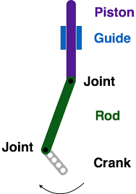

This limitation is not present in our design due to the different method of mechanical energy transfer. Hence, a much greater voltage can be obtained due to the greater stroke length within a smaller setup. Also, since the most of any minimal frictional losses present are shared by 8 thermodynamic systems than a single system, the percentage frictional losses are also reduced.

The gas cycle in the engine is as follows:

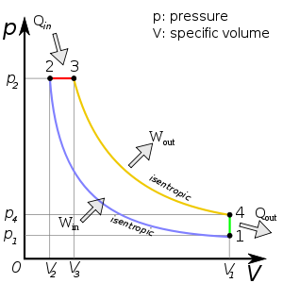

**ALTERNATOR**

The alternator consists of two parts – the magnetic setup and the coil. The magnetic setup is arranged to the inner pistons and the coil is attached to the outer pistons. The magnet and the coil oscillate with a phase difference of 180 degrees and has an air gap of 1mm between them.

***Magnetic Setup:***

Permanent magnets is adopted instead of electromagnets as it abolishes hysteresis losses. It consists of small magnets with optimum thickness as a substitute to a single long magnet. The magnets will have axial slots along its length. Both are done to minimise the eddy current losses in the permanent magnet. The extreme end positions of the magnets are Alnico magnets which has a higher working temperature.

5 Tubular magnets are arranged around a hollow steel cylinder with soft iron rings in the spaces between. The magnets are arranged in an order known as the halbach array. The halbach array is an arrangement that increases magnetic field, almost doubling it, on one side of the tube by redirecting magnetic field lines. On each extreme side of the cylinder is an alnico magnet of strength 1 Tesla.

The three magnets in between are neodymium magnets of strength 2 Tesla. Neodymium has stronger magnetic properties than alnico. However, we are using alnico magnets because of their persistent magnetic properties even at high temperatures. Alnico magnets have a curie temperature of 800 degree Celsius, and a working temperature of 540 degree Celsius. This ensures that the ends of the magnetic arrangement are not affected by any high temperatures that might possibly reach the magnetic setup.

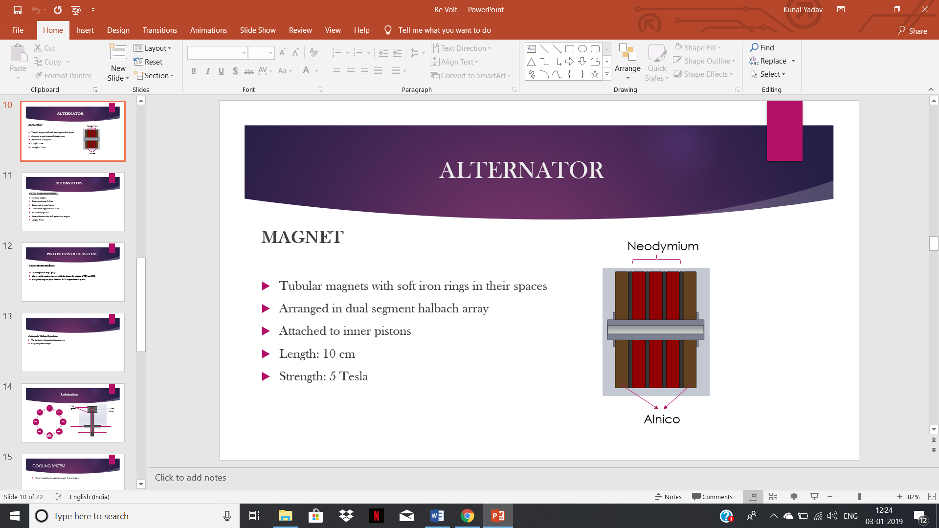

***Dimensions of Magnetic Setup:***

The total length of the magnet will be 10 cm.

***Alnico and Neodymium magnet:***

Inner diameter of magnet: 4 cm

Outer diameter of magnet: 8 cm

Width of magnet: 1.2 cm

***Soft iron rings in spacing:***

Inner diameter of core: 2 cm

Outer diameter of core: 4 cm

Width of core: 1 cm

***Dual Segment Halbach array:***

The magnets are arranged in such a way that the magnetic field lines are redirected such that the magnetic field is almost algebraically added on the outer side of the magnet. Magnetic field lines due to dual segment halbach array:

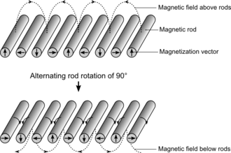

***Moving Windings:***

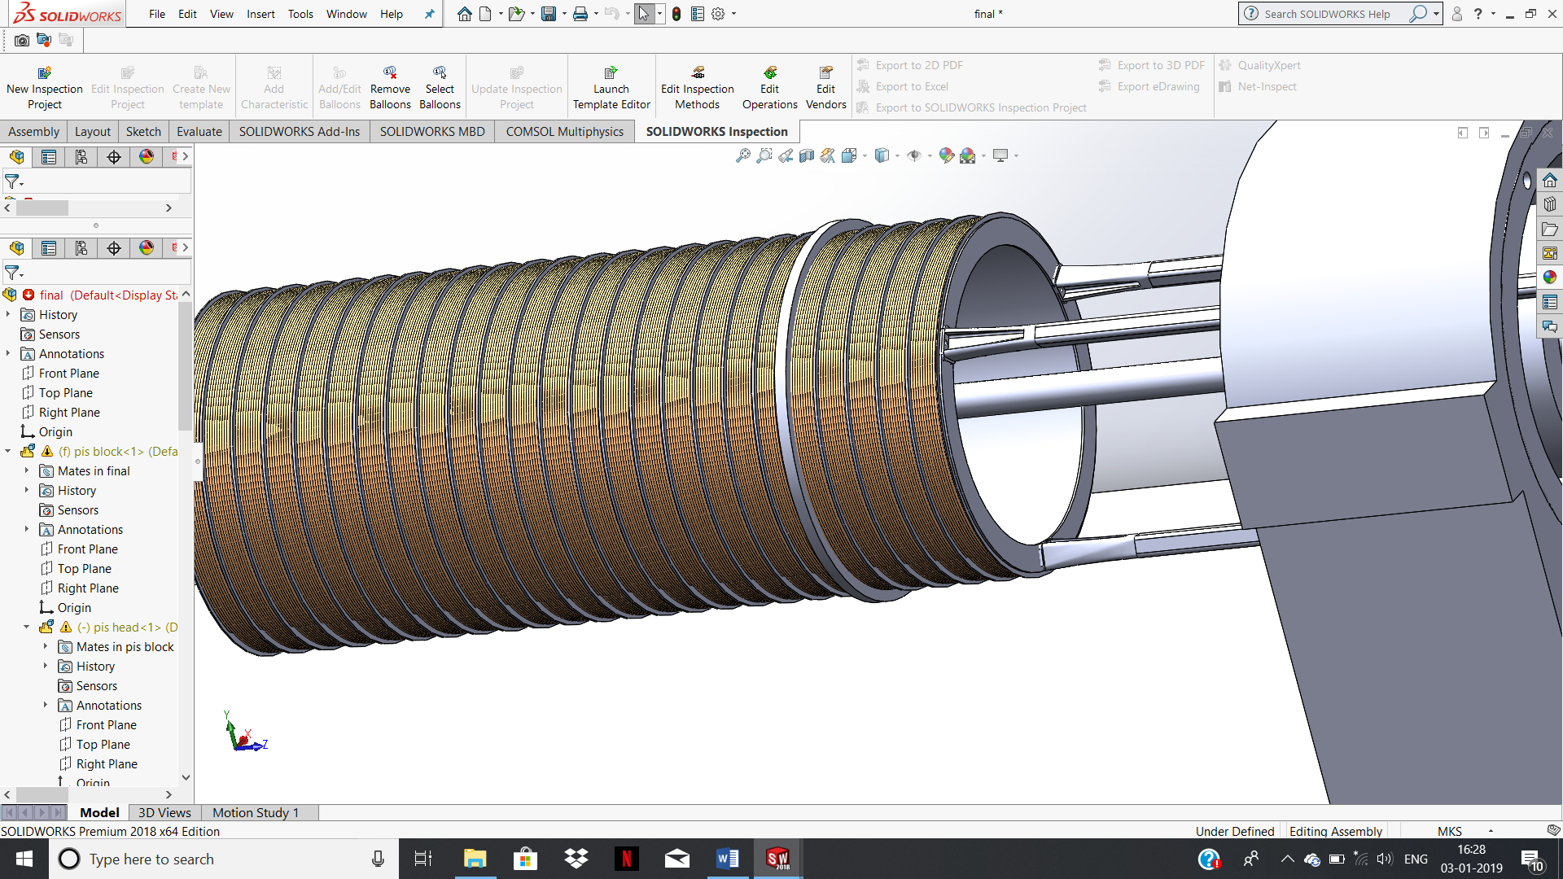

The coil consists of 500 turns of copper wire wound around a diameter of 8.2 cm. This gives an air gap of 1 mm. The diameter of the copper wire is 1 mm. The diameter and number of turns are decided based on compromises between flux linked, space constraints and resistance. A greater number of turns gives a larger flux. However, increasing the number of turns while keeping the diameter constant would increase the length and hence the space occupied by the coil. The coil is connected by three equiangular spaced rods to the outer pistons. The coil oscillates with a phase difference of 180 degrees to the magnetic setup with an amplitude of 10 cm. This means that at all times, the coil and the magnet are moving with equal speed in opposite directions. This arrangement allows for a resultant amplitude of 40 cm relative to the coil.

***Power transmission from windings;***

Contact brushes is used to transmit the current from moving windings to the stationary copper wire present outside the windings. It will be always in contact the copper wire. It is coated with graphite as it is a good conductor and has lubrication properties.

### **PISTON CONTROL SYSTEM**

#### **Piston Control Unit:**

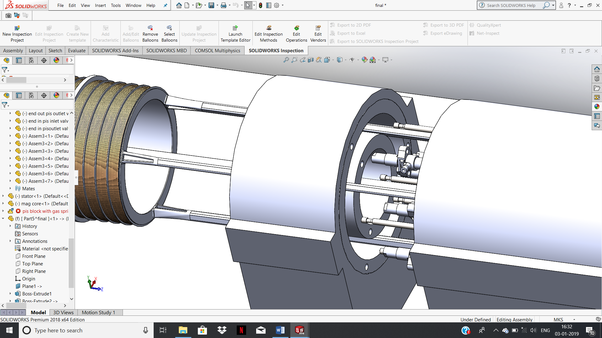

Unlike conventional internal combustion engine, the piston dead centres and the stroke length in our model are not restrained by the mechanical structure. Hence, this allows the compression ratio to be adjusted by controlling the position of the piston and thereby regulating the top dead centre. Different fuels such as gasoline, hydrogen, and methane can therefore be used in our model with their optimal compression ratio. For this the engines are integrated with Linear Electric Machine or LEM and gas spring. The piston moves freely between TDC and bottom dead centre (BDC), and its motion is determined by the resultant force that is acting upon it, including gas pressure force, electro-magnetic, and rebound force. The piston motion must be controlled by an electronic control system-LEM. LEM controls the variables and parameters in gas springs which adjusts the TDC and BDC and hence compression ratio. The LEM also acts as starting method for engine. LEM is also responsible for keeping a phase difference of π between the concentric cylinders.

***Automatic Voltage Regulator:***

If the load on the generator is variable, the emf produced by the alternator coil should vary accordingly. This is done by Automated Voltage Regulator (AVR). AVR changes the fuel injection rate according to load which in turn changes the emf induced in stator coil.

**FUNCTIONS OF CONTROLLABLE GAS SPRING**

A gas spring is used to reduce the fluctuations of compression ratios by diminishing the dependence of previous combustion for compressing the inlet charge. The compression ratio is altered by changing the amount of air present in both sides of the chamber in gas spring. It will be paired up with high pressure and low pressure cylinder for altering the amount of gas. The values for these are controlled by the control unit according to varying parameters. The starting of the generator will be done with the help of this gas spring.

**LUBRICATION SYSTEM**

Lubrication is necessary in order to reduce the frictional losses present in the system. The three rings which are present between the cylinder block and the piston for sealing the combustion chamber, improving heat transfer between piston and cylinder walls, scraping the oil at the cylinder walls to prevent combustion of it.

Two separate lubrication systems connected to a single lubrication pump are needed for lubricating the piston rings and the rings for the connecting rod (conrod). Rings are provided for the connecting rod to reduce the friction and to make the chamber gas tight. Inlet and exhaust holes are bored in the bottom side of the cylinder block. The oil will be pumped into the holes with the lubrication pump. This oil settles at the space between two rings. The oil will be drained out with exhaust hole which will be at an angle of 170 degrees from inlet hole. The oil will be flowing to the sump and keeps on circulating within the system. For piston rings lubrication, holes will be in the conrod of the inner and outer pistons. There will be two inlets in the circumference of the piston. One will be below the top set of rings and other will be at top of bottom set of rings. The exit will be placed at the centre of inlet valves which will be linked with exit orifice to sump with a slacked flexible tube.

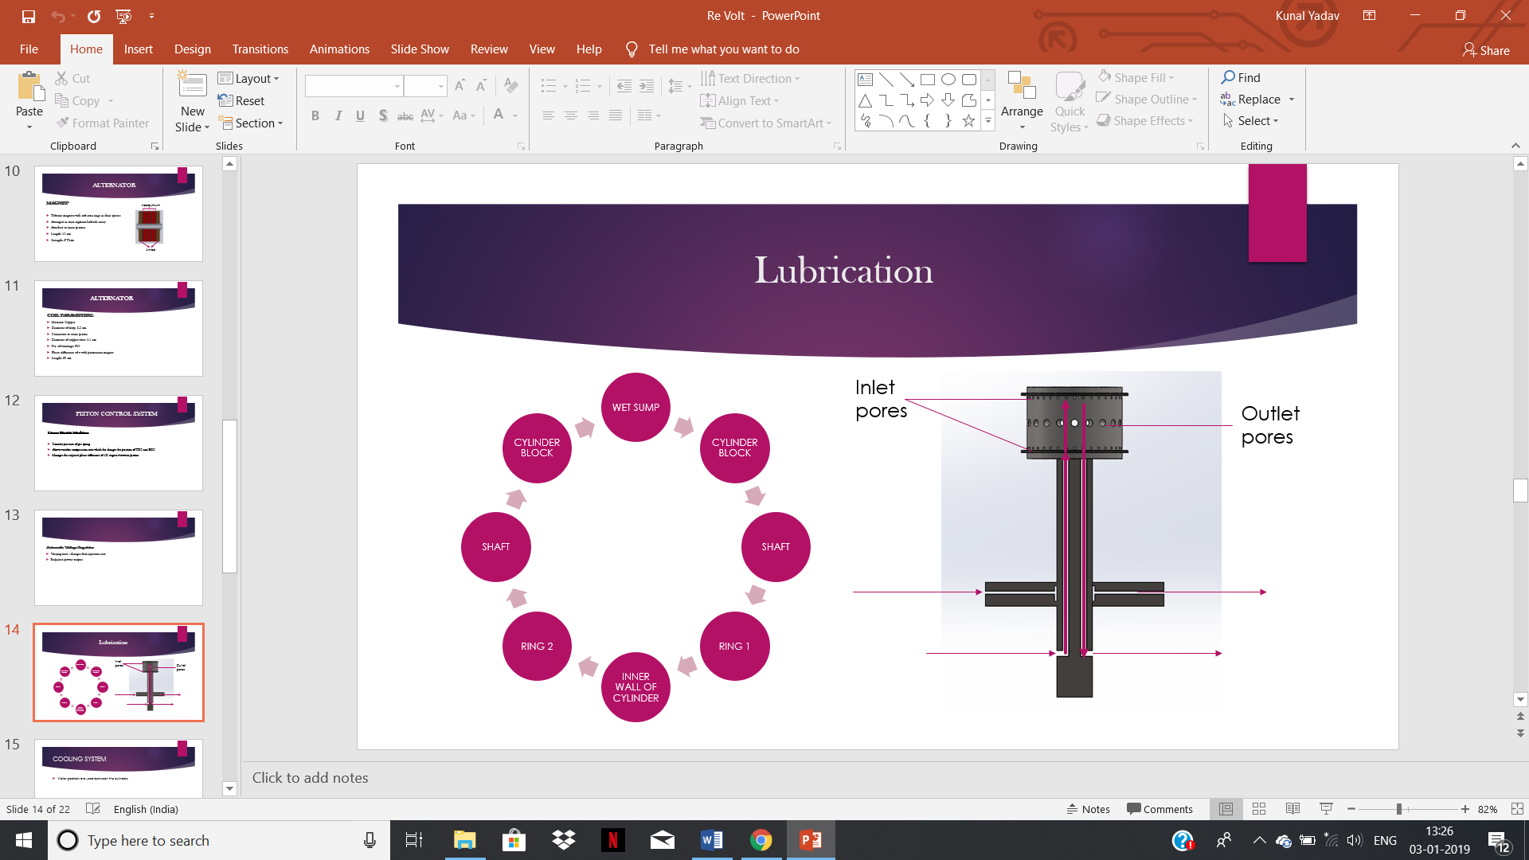











***Lubrication oil:***

Synthetic oils are chemically synthesised to meet the exacting demands of modern engines. This makes them more expensive to produce, but because they are tailor-made they provide the best performance, protection and fuel economy. They also remain stable at very high temperatures and fluid at very low temperatures. The advantages of synthetic oil compared to mineral oils are as follows:

* Better lubrication at both hot and cold temperatures
* Potentially increased horsepower and torque due to reduced friction
* Enhanced cleanliness and superior engine protection
* Increased stability and endurance – the oil lasts longer and needs to be changed less frequently
* The potential for improved fuel economy

**COOLING SYSTEM**

The heat transferred to connecting rods by combustion has to be cooled before reaching the permanent magnets as its retentivity decreases with rise in temperature of magnet. Water jackets will be situated around the piston in the cylinder block. The water flows continuously which carries away the heat from the cylinder. The hot water gets cooled with the help of coolant fan in the system. The coolant will be sprayed to decrease the temperature of the conrod with a nozzle from outside. The rings for the conrod will scrap off of the coolant to the sump.

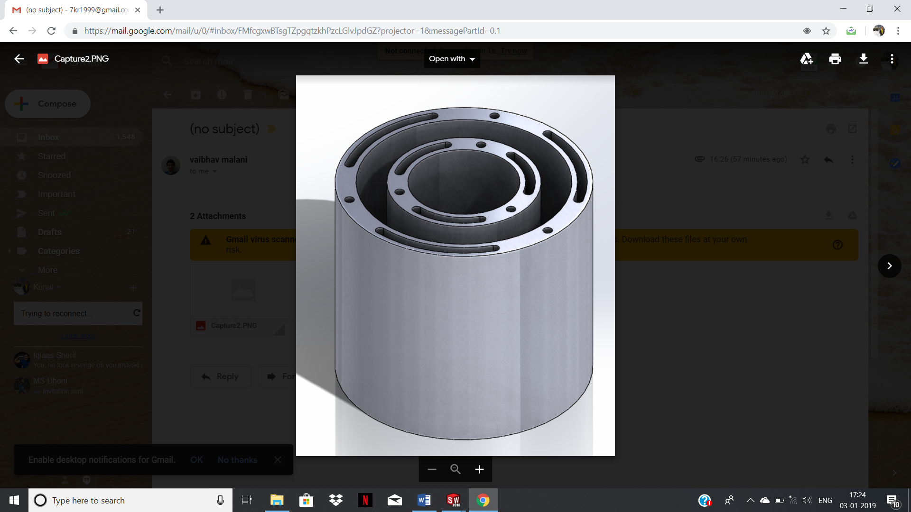

**TECHNOLOGIES TO INCREASE THE OVERALL EFFICIENCY**

***Turbochargers;***

The turbocharger is a device which harvests the kinetic energy from exhaust gas and utilises it to run the compressor which is present to force the appropriate quantity of air required for fuel combustion. The exhaust gas drives the turbine which powers the compressor. It increases the efficiency and power of the system as it converts the waste energy of the exhaust gas to useful work.

***Low Temperature Combustion:***

The combustion will happen at low temperature as it reduces the NOx and Particulate Matter (PM) emissions. A part of exhaust gases can be recirculated back into the combustion chamber which absorbs the heat which reduces the NOx content. It also achieves high level of thermal efficiency from the given fuel. A classification of LTC known as RCCI is assimilated in our model.  RCCI aims to gain more control over combustion phasing by using multiple fuels of differing reactivities in a compression ignition engine. Multiple injections of these various fuels at scheduled intervals provide control over the reactivity of the charge in the cylinder for optimal combustion duration and magnitude. A relatively low reactivity fuel is injected early in the engine cycle and mixed homogeneously with the air. Later in the cycle, a higher reactivity fuel is injected into the cylinder. This approach creates pockets of differing air/fuel ratios and reactivities, causing the combustion to occur at different times and at different rates. Multiple injection systems are required to run an RCCI engine. Permutations of this approach have been demonstrated with all combinations of gasoline, diesel, and natural gas as well as several biofuels and boutique fuels.

**ANALYSIS OF EMF PRODUCED**

***Mathematical Model:***

Consider the Magnetic arrangement to be a dipole of magnetic moment M.

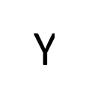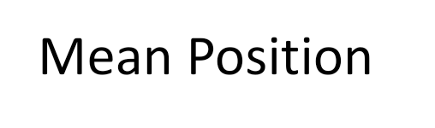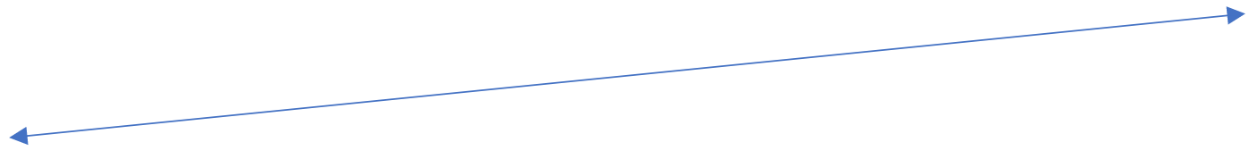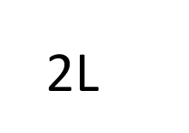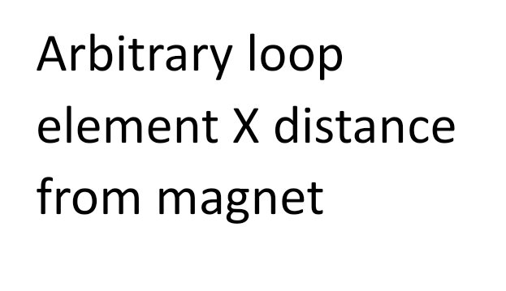

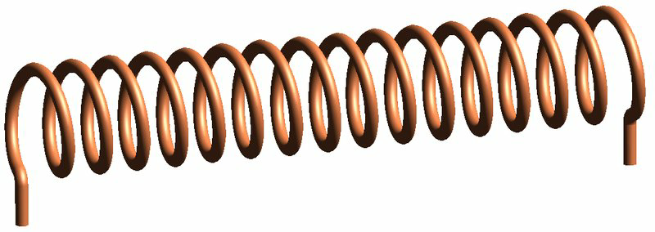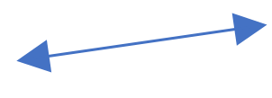

The first step is to find the magnetic flux passing through a loop of wire at a distance X from the magnet. The field needed here is the field perpendicular to the plane of the loop of wire.







The axial and the equatorial fields due to the components of the pole can be found at any point on the coil. The vector components of the two along the horizontal are added to find the net horizontal magnetic field at a radial distance ‘r’ from the centre of the coil. The flux passing through area elements of area 2*pi*r*dr are integrated for values of r ranging from 0 to R. This gives us the flux passing through a coil element at a distance x from the magnet.

The expression obtained is integrated for values of X ranging from –(W+Y) to (W-Y). This gives us the value of the total flux linked with the entire coil as a summation of the fluxes linked with all the loops.

Then we replace the variable Y with ‘ASin(2*pi*f*t)’ in the expression obtained for the total flux linked and differentiate it with respect to time to get the value of the EMF induced in the coil.

**FEA ANALYSIS**

The entire model has been analysed using Comsol for magnetic flux linkage of permanent magnets. Ansys 16 is used to find the temperature distribution on the double acting piston head once after the combustion takes place. The materials have been chosen according to requirements of each and every component.

***Comsol analysis:***

Upon analysis in Comsol Multiphysics, the voltage induced across the coil due to one setup was found to be 160 Volts. The flux linkage between magnets and coils are shown in the diagram below:

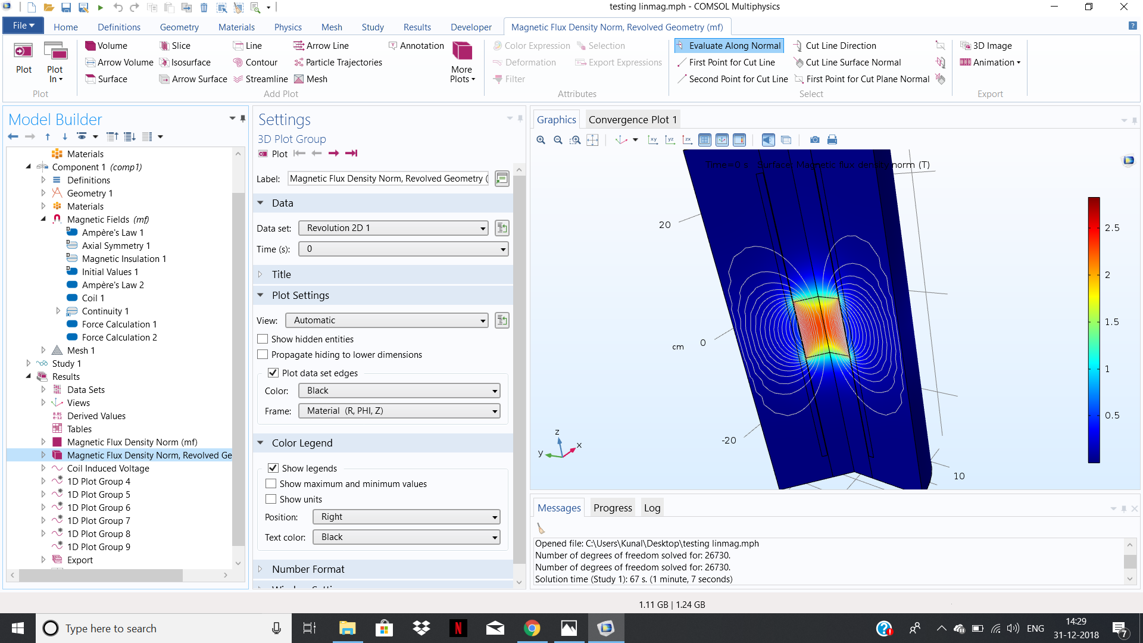

Frequency: 60 Hz

Magnetic strength: 5 Tesla

Amplitude: 20 cm

Coil wire diameter: 1 mm

Loop diameter: 82 mm

Number of Turns of Coil: 500

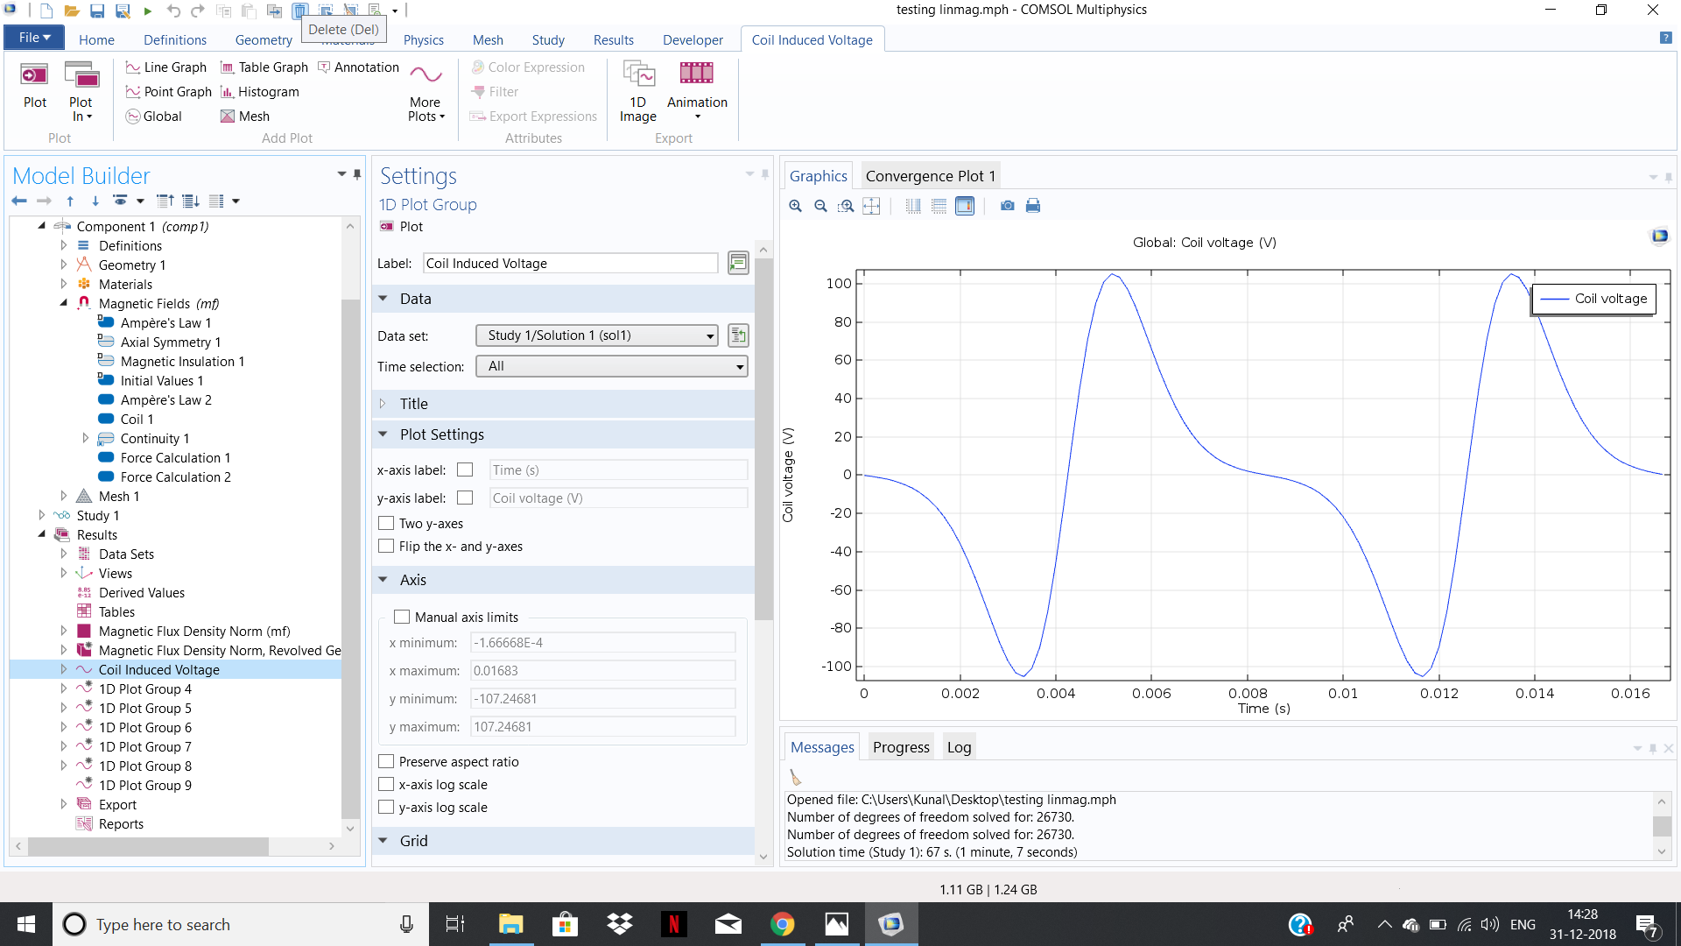

Upon taking the circuit load to be similar to be that of 150 100 watt bulbs, the power generated by the setup was found to be 12 kW. Almost all the flux passes through the coils which minimises the magnetic flux leakage losses.

Assuming losses due to friction to be 5 % of the output and with a 50 % thermal efficiency of the engine, the heat input required was found to be

12 X 1.05 X 2 kW = 25.2 kW

Heat value of Diesel = 45 MJ / kg

This gives us the fuel input required by the setup, which is

Heat Input (in Watt) / Heat Value of fuel (in Joules per Kilogram)

= 25.2/45000 kg/s

= 0.00056 kg/s

=0.56 g/s

For an output electrical power of 12 kW, this gives us a specific fuel consumption of

SFC = **167.4 g/kWh**

***Ansys analysis:***

Once the air fuel mixture gets burned in the combustion chamber there will be sudden rise in temperature and pressure in chamber. This leads to increase in temperature on the piston head which has to transfer to the cooling system regularly.

The piston is analysed by putting appropriate materials and the diagram of it shown below:

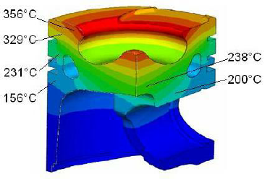

Sine combustion also occurs on the side of the connecting rod, the highest temperature is considered for conduction. This temperature further drops down as we move along the length of the rod, also passing through the lubricated region. As a function hinderance preventive measure, we have used alnico magnets on the edges of the magnetic arrangement. This is because they have a curie temperature of 800 degree Celsius and a working maximum temperature of 540 degree Celsius, both of which are much higher than those of neodymium.

**MATERIAL ANALYSIS**

|  |  |  |  |
| --- | --- | --- | --- |
| **Sl. No** | **Sub-system** | **Component** | **Material** |
| 1. | **Diesel Engine** | Cylinder Block | Grey Cast Iron |
|  |  | Inlet Valve | High chromium stainless steel |
|  |  | Exhaust Valve | Martensitic steel with chromium and silicon alloys |
|  |  | Fuel Injector | Light duty components - Aluminium/Low Carbon Steel  Heavy duty components - Hardened Steel |
|  |  | Piston | Cast aluminium alloy |
|  |  | Piston Rings  a. Seal ring     1. Heat transfer ring 2. Lubrication ring | Si-Cr Steel with Phosphate side coating and Cr top coating  Plain Carbon steel with Fe3O4 side coating and Cr Top Coating  Austenitic Stainless Steel with Salt Bath Nitriding |
|  |  | Connecting Rod | Powder Metal Steel |
|  |  | Connecting Rod ring | Powder Metal Steel |
|  |  | Intake Manifold | Plastic and Aluminium |
|  |  | Exhaust System | Stainless steel, Aluminium and Iron |
| 2. | **Alternator** | Permanent Magnet | Alnico and Neodymium |
|  |  | Winding Core | Iron |
|  |  | Winding | Copper wires |
|  |  | Tube | Synthetic Rubber |
| 3. | **Air Chamber** | Gas spring | Stainless steel |
| 4. | **Lubrication** | Flexible tube with spring | Rubber |
|  |  | Lubrication oil | Synthetic oil |
| 5. | **Cooling** | Coolant | Water |
| 6. | **Turbochargers** | Turbine wheels | Nickel based super alloys |
|  |  | Compressor wheels | Aluminium alloy |
|  |  | Casing | Austenitic steel with high nickel content |

**ADVANTAGES OF OUR MODEL**

***Reduced Thermal Loss:***

Compared to a normal generator that would have, say, 8 cylinders, this design has a much lower surface area exposed to the surroundings for heat to escape. When the cooling system of an engine takes away heat to prevent overheating of parts, it is essentially resulting in a loss of energy from the system. In this design, some of the heat from the inner cylinder released during its power stroke, when passing through its curved surface area is passed on to the outer cylinder. At this time, the corresponding thermal system in the outer cylinder is undergoing the exhaust stroke. The heat input from the inner cylinder works in a way to increase the temperature of the exhaust gases and therefore makes the turbocharger process more efficient. The same applies for the exhaust gases coming from the inner thermodynamic systems during power strokes in their corresponding outer system. The excess heat input would not cause overheating of the parts because during the exhaust stroke, the temperature is much lower than that during combustion, which is within the safer temperature range of the parts of the engine.

***Mechanical Efficiency:***

***Vibration losses:***

* In a normal crankshaft engine, there is a large net force on the engine block during mainly the power stroke which can cause vibrations as the engine block is held in place by its connections and joints. Here, the outer and inner piston arrangements are always moving with an equal magnitude of velocity in the opposite direction. This ensures that the net force acting on the engine block is greatly reduced. While the power stroke at a certain time in the inner cylinder exerts a force in one direction, which in the outer cylinder exerts a force in the opposite direction. The concentric arrangement when compared to a side by side or a top bottom arrangement enormously reduces the torque exerted on the engine block and thereby the vibrations caused by it.
* The magnetic arrangement is such that the magnets and the soft iron rings between them are tubular. They are fixed on to a hollow steel tube using clamps at the ends. The hollow tube instead of a solid core increases the moment of inertia of the arrangement along an axis perpendicular to the axis of the tube and thereby reduces the bending stress and deflections that might have otherwise led to vibrations.

***Friction losses:***

* In a crankshaft engine, the joint between the crankshaft and the connecting rod is a major region of frictional loss in the generator. The absence of this joint removes these frictional losses. According to research, the friction loss in a crankshaft engine amounts to approximately 15 % whereas that in a linear generator amounts to approximately 8 %. This 8 % is for the loss at the crankpin for a single piston and its connecting rod oscillating. This joint is replaced by a direct rigid connection between the piston and the hollow steel tube on which the magnets rest for the inner pistons and the coil for the outer pistons. The sliding contact between the engine block and the shaft is shared by two thermodynamic systems, which again reduces overall friction losses.
* The friction between the piston rings and the inner wall of the piston cylinder is also a major source of mechanical energy loss. In a crankshaft engine the piston receives considerable forces in the horizontal direction due to the angle with that the connecting rod makes with the axis of the connecting rod. These forces are minimal here as the connecting rod remains rigidly attached along the axis of the piston.
* Overall, the whole design has reduced friction losses in the regions where they would have otherwise been high. Importantly, the regions where these losses are incurred are shared by multiple thermodynamic systems, thereby leading to a reduced frictional loss percentage for the same power output.

***Versatility:***

The functioning of our model at variable loads and variable compression ratios makes it more versatile.

***Compactness:***

The removal of crankshaft and flywheel from the engines provides a very compact setup.

**FUTURE SCOPE FOR IMPROVEMENT**

The model can further modified in the following ways:

* The cooling
* The lubrication system can be improvised.
* Too precise synchronisation of coils and magnet can be implemented.
* Sound absorbing materials can be added for noiseless operation.

**CONCLUSION**

Re-volt has a lot of benefits compared to that of conventional diesel generators and existing linear generators. This model will increase the brake thermal efficiency of the generators which leads to greater power output. The effects of change in load during its running has been regulated by the apparatus by its own. This unit will be efficient and effective with present products. Hence a successful free piston linear generator has been designed.

**REFERENCES**

[**https://www.researchgate.net/publication/224986992_Investigation_of_a_high_efficient_free_piston_linear_generator_with_variable_stroke_and_variable_compression_ratio**](https://www.researchgate.net/publication/224986992_Investigation_of_a_high_efficient_free_piston_linear_generator_with_variable_stroke_and_variable_compression_ratio)

[**https://en.wikipedia.org/wiki/Pantograph_(transport)**](https://en.wikipedia.org/wiki/Pantograph_(transport))

[**https://link.springer.com/article/10.1007/s38313-013-0099-z**](https://link.springer.com/article/10.1007/s38313-013-0099-z)

[**https://www.researchgate.net/publication/327127242_A_Review_of_the_Design_and_Control_of_Free-Piston_Linear_Generator**](https://www.researchgate.net/publication/327127242_A_Review_of_the_Design_and_Control_of_Free-Piston_Linear_Generator)

[**https://www.semanticscholar.org/paper/A-Free-Piston-Linear-Generator-Control-Strategy-for-Zhang-Chen/cc0f8b0feabee00ac1dbe8971298c08e51d782af**](https://www.semanticscholar.org/paper/A-Free-Piston-Linear-Generator-Control-Strategy-for-Zhang-Chen/cc0f8b0feabee00ac1dbe8971298c08e51d782af)

[**https://pdfs.semanticscholar.org/a6a4/fe26315fe589c99cd9f087b3918bffbf62a9.pdf**](https://pdfs.semanticscholar.org/a6a4/fe26315fe589c99cd9f087b3918bffbf62a9.pdf)

[**https://www.revolvy.com/page/Linear-alternator**](https://www.revolvy.com/page/Linear-alternator)

[**https://www.digitaltrends.com/cars/road-rave-free-piston-engines-power-next-plug-hybrid/**](https://www.digitaltrends.com/cars/road-rave-free-piston-engines-power-next-plug-hybrid/)

[**https://www.extremetech.com/extreme/185789-toyota-develops-high-efficiency-free-piston-no-crankshaft-combustion-engine-to-power-an-ev**](https://www.extremetech.com/extreme/185789-toyota-develops-high-efficiency-free-piston-no-crankshaft-combustion-engine-to-power-an-ev)